How to Clock In
- Find your name
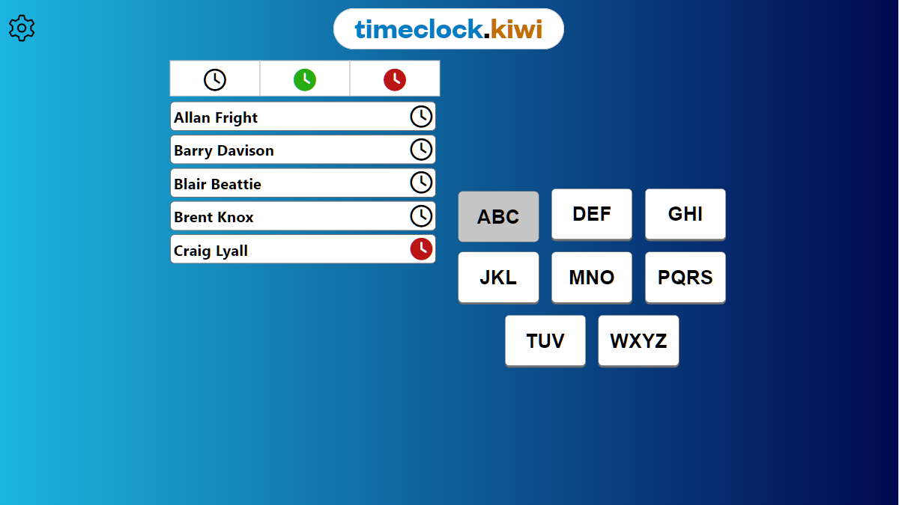
1.Filter
2. Your name

- Hold down Clock In button
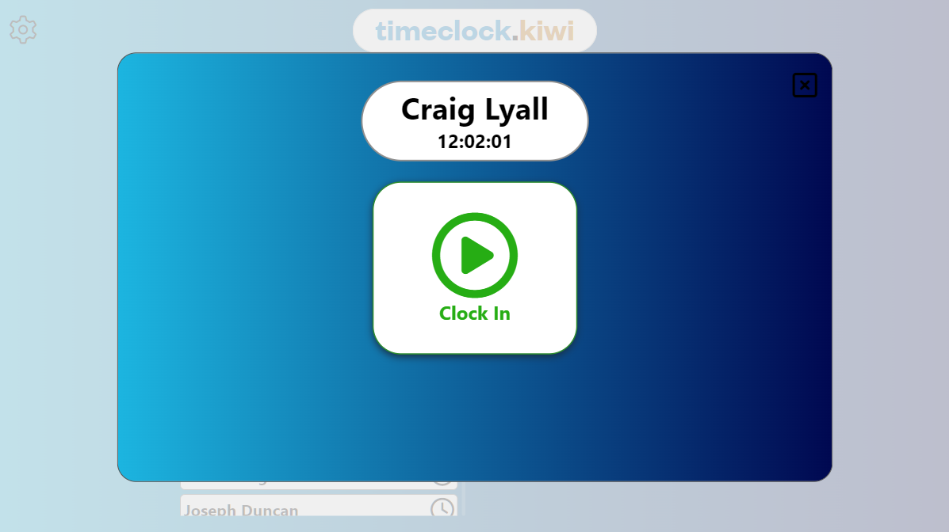
3. Hold for 1 second

